1.8 Hyperbolic Trigonometric Functions Worksheet

- Consider the region R determined by the curves , , , and .
- Sketch a picture of the region R.

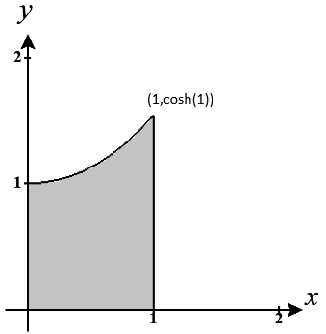

- Set up, but do not evaluate, an integral which represents the area of the region R.

We note that .

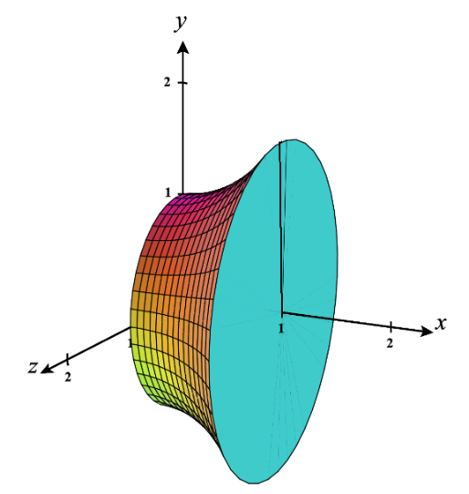
- Suppose that R is revolved around the x-axis to create a solid. Setup, but do not evaluate, an integral which represents the volume of the solid.

.

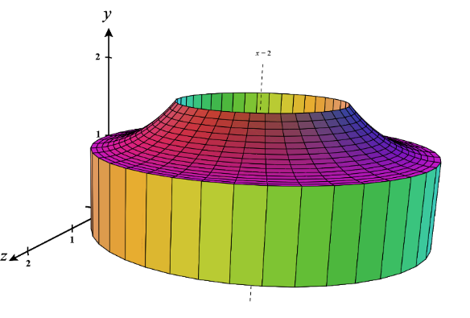
- Suppose that R is revolved around the line to create a solid. Setup, but do not evaluate, an integral which represents the volume of the solid.

.

- Consider the region R determined by the curves .
- Sketch a picture of the region R.

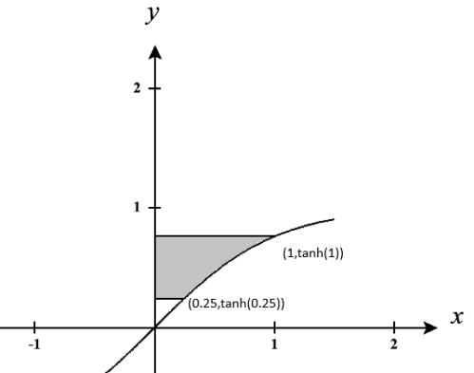

- Set up, but do not evaluate, an integral(s) which represents the area of the region R.

- Suppose that R is revolved around the line to create a solid. Setup, but do not evaluate, an integral which represents the volume of the solid.

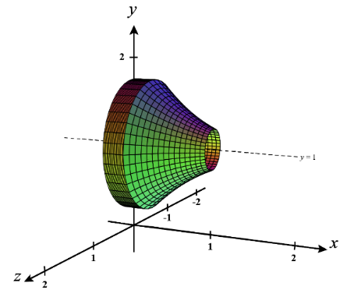

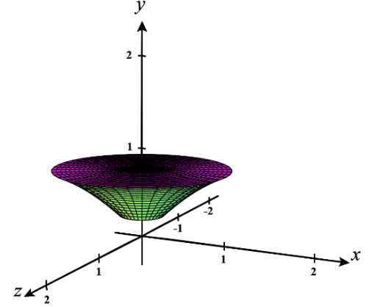
- Suppose that R is revolved around the y-axis to create a solid. Setup, but do not evaluate, an integral which represents the volume of the solid.

- Consider the curve on .
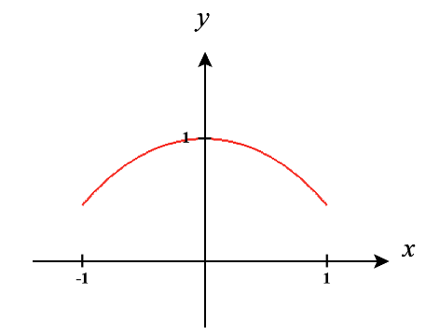
- Setup, but do not evaluate, an integral which represents the length of the curve.

We note that is continuous on

- Suppose the curve is rotated around the x-axis. Setup, but do not evaluate, an integral which represents the surface area of the resulting surface.
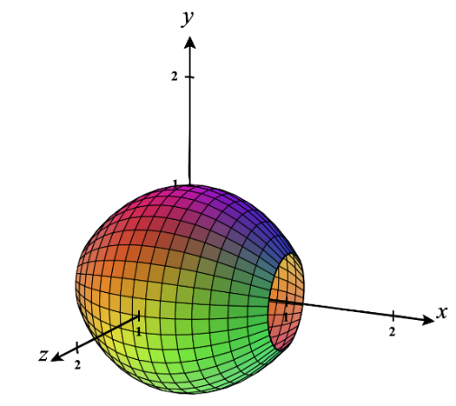
Note that is non-negative on and is continuous on .

Therefore, the surface area is given by .

- Consider the curve on .
- Setup, but do not evaluate, an integral which represents the length of the curve.
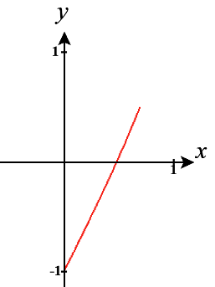
We note that is continuous on .
Therefore, the arc length is given by .

- Suppose the curve is rotated around the x-axis. Why are we not able to use the surface area formula here to help find the surface area for the resulting surface?

The issue here is that on the interval the function is negative and therefore the conditions to use the surface area formula are not met.

- Suppose that we now consider the curve on the interval . If this curve is rotated about the x-axis, then setup, but do not evaluate, and integral which represents the surface area of the resulting surface.
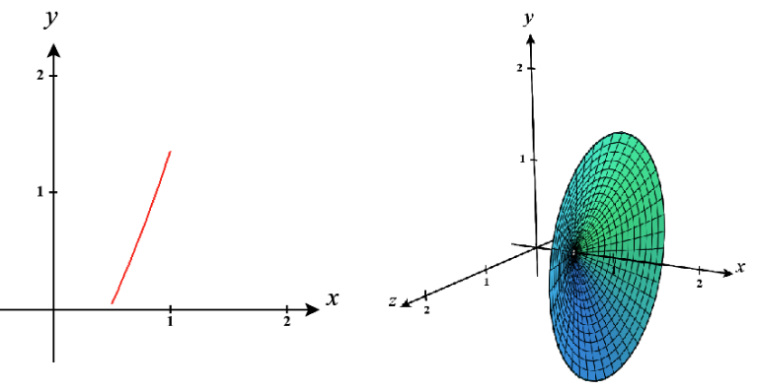
Note that is non-negative on and is continuous on .

Therefore, the surface area is given by

.

- Suppose that the same curve from part (c) is now revolved about the y-axis. Setup, but do not evaluate, and integral which represents the surface area of the resulting surface.

It isn’t easy to solve our equation for x, so we will plan to set up this integral with respect to x. We already saw in part (c) that is non-negative and is continuous on. Therefore, the surface area here is given by

